

Tangshan UANCHOR Automation Technology Co., Ltd.

Digital Inkjet Printing Machine
（PM1040）

Catalogue

- Introduction and advantages............................3

- Technical parameter...................................5

- Introduction of mechanical structure......................11

- Configuration description...............................12

- Service content........................................16

- Company profile.......................................18

Digital Inkjet Printing Machine PM1040
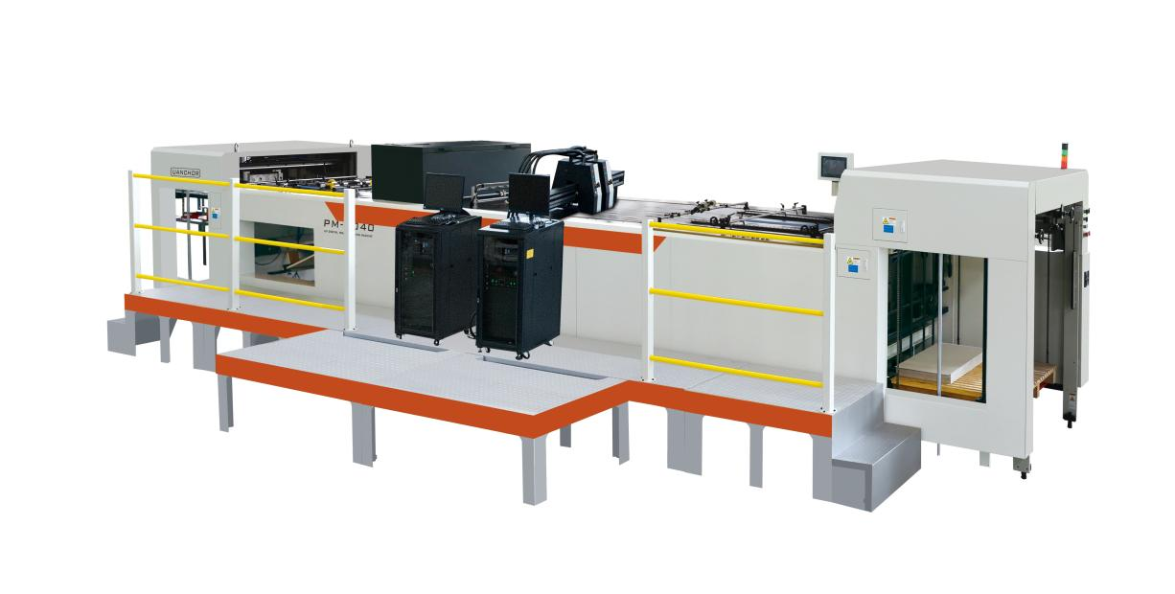
Plan:
PM1040 High-speed and high-precision paper feeding platform+
H10000-G（4UV）High-speed inkjet system+
16K linear array camera variable data detection and scrap system+
UV-LED Curing system
一、Advantages：
- The most advanced printing technology
It adopts Japan Ricoh Gen5 high-speed industrial printing head, the spray printing accuracy can reach up to 600x900DPI,and the printing frequency can reach 30kHz,it is one of the fastest industrial printing heads at present,the size of the ink dot is 7-35pl adjustable，and the fineness is extremely high with excellent printing effect.Using the latest foreign inkjet control technology and nozzle drive components,combined with the R&D integration of UANCHOR's mature control system, make full use of the performance of Ricoh Gen5 nozzle and the stability advantage is significant.
- 16K linear array camera variable data detection and scrap system
➢One-dimensional code detection: real-time online detection of whether the one-dimensional code data is duplicated, and whether the one-dimensional code is deviation, broken, dirty, white bar, missing, etc.
➢ Two-dimensional code detection: real-time online detection of whether the two-dimensional code data is duplicated, whether the two-dimensional code is deviation, missing, and whether the two-dimensional code is readable.
➢Anti-counterfeit verification: real-time online two-dimensional code and verification code for correlation verification.
Automatic rejection of single sheet defects: if any defects are found in a single sheet, the rejection signal will be sent out in real time and accurately (so that the operator can find the defects as quickly as possible).
Automatic shutdown when the continuous defects are found: the system will send out a signal in time automatically controlling the feeder to stop feeding paper in the case of that there are continuous defects appeared (to an extent, avoid the waste because of the breakdown of machine immediately). It can output the detection data connecting with the management software of customers such as MES or ERP.
- LED-UV curing system
Inkjet printing system adopts imported LED ink that is environmentally-friendly, and the corresponding curing system adopts LED cold light curing system which is emitting no more exhaust, saving the energy, and there is no deformation generated to the solidifying paper and other materials.
Control of light source: cold light source, quick start, chip integration, high energy with low power, and low calorific value.
Control of power supply: imported power module, no interference, independent research and development chip, automatic protection for undervoltage and overload.
Temperature control system: Humanized intelligent design, automatic temperature protection and water flow detection protection.
Cooling mode: adopt water cooling mode to dissipate heat, effectively lengthen service life and reduce light attenuation.
Radiation area: the radiation area of a single lamp holder: 60mm*160mm
Simple operation: one-button dimming, convenient and safe operation.
- High-speed and high-precision paper feeding platform: high performance, high precision, high speed and wide adaptability:
♦The net weight of the paper transportation platform is 9.6T, and the structure is shock resistance designed and tested to ensure the stability of running.
♦Wallboards and adsorption platforms are made of high-quality steel and processed by large-scale processing centers;
♦The shafts and rollers running at high speed of the machine are all treated by quenching and tempering, qualitative analysis and dynamic balance;
♦The transportation platform is steel structure with thickness of 25mm, which ensures the operation process of vacuum platform to be more stable;
♦It can be applied to the printing of thin or thick paper, etc., with a weight range of 80-450g and wide adaptability;
♦The maximum paper size is 1040×1040 mm, and the paper can be transported horizontally and vertically, which is the first choice in China;

♦Adopt a unique rectifying correction and positioning device, The precision of spray printing on the front, back, left and right is up to ±0.1mm (one and only in China), which meets the requirements of cigarette packs;
♦Platform maximum speed can reach 150 m/min, meeting the higher needs of jet printing in the future;
♦The bought-in components and electric components for equipment are both selected from well-known brands at home and abroad, as shown in the following table.
♦High-platform paper pile and collection, and spray printing operation surface height is moderate, which is easy for operation, improving production efficiency and reducing labor intensity;
二、Technical parameters
Comprehensive technical indexes of H10000-G single-sheet high-speed inkjet printer
Inkjet printing system configuration

Model of inkjet printing machine |  | H10000-G
Type of printing head |  | Ricoh Gen5
Wideness of printing head |  | 54 mm
Max.number of printing head |  | Support 16 groups of printing unit mostly
Max.spray printing precision |  | 600×1200dpi
Size of ink dot |  | 5PL，10PL
Max.speed of spray printing |  | 110m-130m/min under the stable production, ensuring the quality
Grade of printing |  | 99%A
Type of ink |  | LED-UV eco-friendly ink, with passing CMA qualification and VOC detection
Color of ink |  | Black, blue, light cyan, magenta, true red, white, yellow, purple, green, etc., and also support special inks such as colorless fluorescent ink.
Spray printing media |  | Gold and silver cards, paper, stickers, metal foil, UV white ink, opp and other films.
Ink supply system
Principle of ink supply |  | Based on industrial piezoelectric technology, supplying ink by voltage
Mode of ink supply |  | Centralization
Grade of filtration |  | Three-stage filtration to protect printing heads
Two-stage ink station |  | Reduce ink leakage,making jet printing effect more stable
Control system
Primary control system | Independent primary control software, advantec original industrial computer，and burn Windows operating system with a random copy
Data transmission | Ethernet transmission, universal and convenient, with the best stability.
Control module | Real-time display parameters such as ink temperature and voltage of printing heads
VDP software system
Data composition | Support common one-dimensional code and two-dimensional code that meeting the international standards  Data format supported as follow:  One-dimensional code：39、128、25、X25、EAN-13、EAN-8、UPC-A、UPC-E、EAN/UCC-128A、EAN/UCC-128B、EAN/UCC-128C、93、Codabar、POSTNET  Two-dimensional code：PDF417、QR、DMTX  Other special code：SD two-dimensional code、color code、other closed code system（dot code etc.）；  Chinese characters, English characters, special characters, and images；  Other modules: rectangle modules, rounded rectangle modules, time modules, table modules, ellipse modules, Bessel modules, curved modules, polygonal modules, arrowhead modules, moved modules, picture modules, verification code picture modules
Data management | - Inkjet composition system （including bar code,two-dimensional code generator，access of the module of database and color code.）  - Data transformation system（including the transformation of file format of text, Access, Excel）  - Spray printing management system（including the management of spray printing data, implement of printing according to page numbers, rejection of printing repeated page number. ）  （4）Database management system（including repeat data checking with multiple batches and this batch of data，the management of data security.)  （5）Color code printing module system（encryption and decryption of data and encryption of color data.）
Anti-duplication code printing | Printed page numbers must not be entered into the printing function again, so as to prevent repeated page numbers from causing duplicate codes.  Data will be compared with the recently printed data before loading to prevent repeated printing.
Calibration printing | Unique bar code calibration function to ensure the printing quality and level

Primary technical indexes of 16K linear array camera variable data detection system
Item |  |  | Index
Max.detection speed |  |  | 120m/min
Max.detection size of product |  |  | 1020mm（horizontal）× 1000mm（vertical）
Imaging precision |  |  | 0.06mm（horizontal）×0.06mm（vertical）
Size of variable printing data | One-dimensional code |  | Min.detection length 23mm
Size of variable printing data | Two-dimensional code |  | Min.detection size ≥8mm*8mm
Detection function | Detection of one-dimensional code | Decryption | One-dimensional code decryption
Detection function | Detection of one-dimensional code | Data comparison | - Compare the result of decryption with inkjet printing document, identifying whether print incorrectly or not  - Compare the result of decryption with detected data, identifying whether there is duplicate printing or not
Detection function |  | Quality detection | - Detecting the defects of wire drawing, dirty, missing appeared on the one-dimensional codes in the process of inkjet printing
Detection function | Detection of two-dimensional code | Data comparison | - Compare the result of decryption with inkjet printing document, identifying whether print incorrectly or not  - Compare the result of decryption with detected data, identifying whether there is duplicate printing or not
Detection function | Character detection | Character recognizing | - Recognize anti-counterfeiting code character
Detection function | Character detection | Data comparison | - Compare the recognized anti-counterfeiting code with spray code text, identifying whether print incorrectly or not  - Compare anti-counterfeiting code with two-dimensional code, identifying are those two codes consistent
Detection function | Character detection | Quality detection | Detecting the defects of wire drawing, dirty, missing appeared on the number characters in the process of inkjet printing
Statistical query | Interface display | Real-time display the position of variable information defects
Statistical query | Statistical function | Real-time count information such as sum of detected products, sum of finished products, sum of defective products, and the proportion of defective products
Statistical query | Defect storage | Real-time keep the information and images of storage defects of products so as to count the defective data
Statistical query | Statistical statement | Support the statistics and management of two-dimensional code data and the printing output.
Rejection mode |  | Sound and light alarm + screening and elimination + automatic shutdown

UV-LED curing system
1.Model：ULD-HPM-900
2.Equipment composition：1 control cabinet+ 1 LED line lamp
3.LED wave band：395nm
4.LED radiation intensity：8-10W/cm2
5.Area of line source：L 900mm * W 10mm
6.Shining height：10-50mm
7.cooling mode：water cooling
8.life of light source：＞20000 hours
9.Dimension of irradiate head：L 110mm * W20mm * H 60mm
10.Power：600-1000W
11.control of light：automatic
12.Power settings：manual
13.Power change：linear（0-10V）/ fixed value
14.Installation：according to requirements
15.Power supply：220V/50-60HZ

LED-UV curing system indexes
Technical items | Indexes
Curing wideness | Curing wideness for single unit lamp head: ≥ 60mm
Curing effect | Cure quickly，spraying code on the surface of paper cannot be eliminated by general detection method，cannot be eliminated by sellotape，meet the standard of friction tester
Curing speed | 120 m/min

High speed and high precision delivery platform
Working speed | 40-150m/min adjustable
Max.paper size | 1060*1040mm
Min.paper size | 400*360mm
Paper thickness | 80-450g/㎡
Precision | ±0.1mm
Total power | 14.5KW
Net weight | 9.6T
Power supply | 3P 380V/50HZ N PE
Dimension | 10200*2000*1800mm（without footboard）
三、Introduction of high speed inkjet printing machine structure
1、Automatic feeding unit
▪Printing feeder with the maximum speed up to 12000 pieces/hour.
▪It is available for printing feeder to move from front to back，which is convenient for feeding paper with large and small size.
▪Gap-free paper feeding can be achieved.
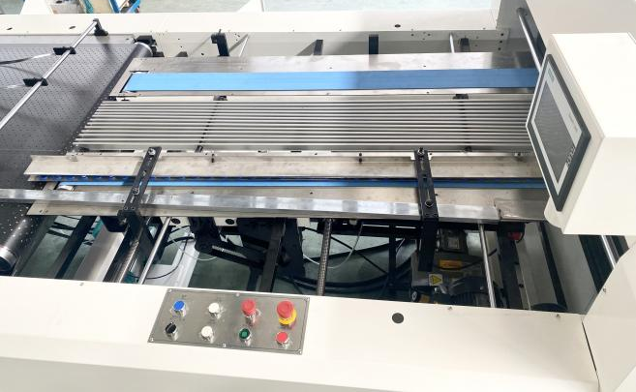
▪Horizontal and vertical paper feeding can be achieved.
▪Delivery part is combined with crossed controller.
▪The feeding part is combined with locating device correcting the straightness accuracy of delivering paper, ensuring the quality of inkjet printing.

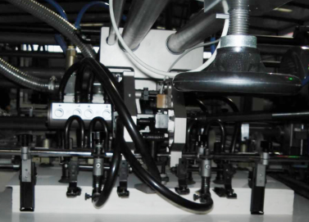
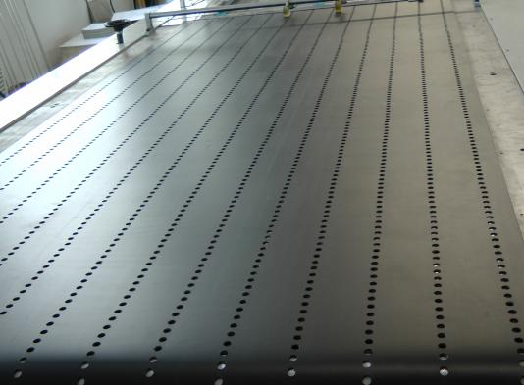
2、Deviation correct and location unit

▪Adopt unique location device, which provides large correction range and it is easy for adjustment.
▪Fluently delivering paper with high stability
♦The side guide part of Uanchor multifunctional inkjet printing platform adopts the unique two-sided REC patent structure（patent：201911390409.8), which is different from other manufacturers with eight-shaped side guide part, and the direction of Uanchor unique side guide part is adjustable, which can be left or right at the same time. This part can ensure that it is more stable to delivery paper and more suitable for efficient and high-speed production.

3、Vacuum adsorption platform unit
▪Vacuum adsorption transport, ensuring good stability and high accuracy.
▪The area of vacuum platform for adsorbing is up to 2600mm，ensuring that the largest paper can finish multi-line and multi-column inkjet printing on the vacuum platform.
▪Transportation platform is steel structure with thickness of 25mm. The structure is shock resistance designed and tested, which is processed by large manufacturer.
▪The whole root of transportation belt is broaden in width which is imported from Germany, making sure that the paper can be delivered smoothly and steadily under the high speed condition.
▪The vacuum fan has strong flow capacity and adjustable air volume, in order to keep the steady of paper.
▪Quick belt replacement design, the paper tape can be disassembled without disassembling the wallboard.
4、UV curing unit
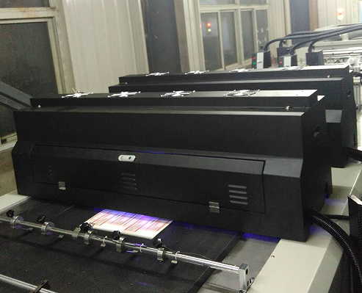
▪Through electro-optical energy conversion, the LED high-power ultraviolet diode chip generates high-purity 395nm monochromatic ultraviolet light, and the energy is highly concentrated in the wavelength band required for curing UV ink.
▪The UV curing equipment is a replacement product of traditional optical fiber high-pressure mercury lamp curing light source machine because its advantages of lower energy consumption, long service life, short curing duration, lower cost, Hg free, and only ordinary electric cables are needed.

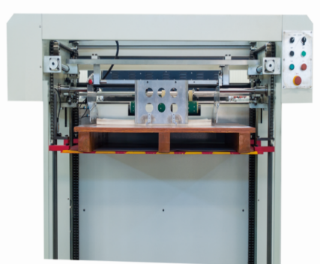
5、Delivery unit

▪Adopts linear guide rail, the delivery gauge can move forward, backward, left and right according to the paper size, which is flexible to adjust and convenient to operate.
▪Left and right side of gauge is convenient to adjust.
▪The paper delivery platform is combined with suction device, making the paper tidy.
▪The delivery part is independently controlled, resulting of the free adjustment of delivering speed.

- Configuration of high speed inkjet printing machine

Configuration of high-speed and high-precision paper feeding platform
Serial number | Name and model | Quantity | Unit | Warranty period
1 | Automatic feeding unit | 1 | Set | One year
2 | Deviation correct and location unit | 1 | Set | One year
4 | Vacuum absorption platform unit | 1 | Set | One year
5 | UV curing unit | 1 | Set | One year
6 | Scrapping unit (corresponding with the online monitoring and warning system) | 1 | Set | One year
7 | Delivery unit（without scale delivery） | 1 | Set | One year
8 | System control unit | 1 | Set | One year

List of main bought-in components of transportation platform
Name | Brand | Name | Brand
Miniature relay | IDEC | HMI | Panasonic
Approach switch | OMRON | PLC | Panasonic
Limit switch | TEND | Air pump | Zhenjiang TONGYOU
Complete frequency converter | TEND | Oven exhaust fan | Shanghai Yutao
Contactor | Schneider | Pneumatic component | SMC、DESTO
Thermal relay | Schneider | Transport belt | ATRZ
Mechanically interlocking auxiliary contact module | Schneider | Electric motor | Taiwan Shengbang
Circuit breaker | Schneider | Photoelectric switch | OMRON
Press button, pull button, pedestal | Schneider | Bearings (except bearing with seat and plane bearing) | C&U
Button contacts, green, red and black buttons | Schneider | Teflon mesh belt | Shenzhen Xingchao

Main configuration of H10000-G（4UV）spraying printing system
Serial number | Name | Quantity | Unit | Comment
List of equipment configuration
1 | Print unit | 4 | Group | Adopts Japan Ricoh Gen5 high-speed industrial printing head
2 | Unit trestle | 2 | Group
3 | Encoder suite | 1 | Set
4 | Indicator suite | 1 | Set
5 | Centralized ink supply suite | 1 | Set
6 | Electric cabinet (including master control system) | 1 | Set
7 | Lenovo original industrial computer | 1 | Set
8 | Ink supply module (including main ink path and ink distributor, ink tube, air tube, filter and solenoid valve) | 1 | Set
9 | One monitor (including a set of mouse and keyboard) | 1 | Set
10 | Other connecting fittings, data cables and network cables | 1 | Set
11 | Software of inkjet printing system | 1 | Set
Installation service consumables
1 | Ink | 2 | L（bottle） | Get for free
2 | Cleaning liquid | 1 | L（bottle） | Get for free
3 | Cleaning wiper | 2 | bag | Get for free

Main configuration of 16K linear array camera variable data detection system
Serial number | Name | Quantity | Unit | Comment
List of equipment configuration
1 | Control software of visual inspection system | 1 | Set
2 | Electrical cabinet (industrial computer, monitor, power supply, components, I/O control board, etc.) | 1 | Set
3 | Imported high-speed 16K linear array camera | 1 | Set
4 | Prime lens | 1 | Set
5 | Acquisition card | 1 | Set
6 | Power supply+6m Camera Link data cable (customized) | 1 | Set
7 | Induction kit (encoder, sensor, induction output port, etc.) | 1 | Set
8 | Warning device | 1 | Set
9 | Dome light source | 1 | Set
10 | Light source adapter | 1 | Set
11 | Rack (customized) | 1 | Set

LED-UV curing system
Serial number | Name | Quantity | Unit | Comment
List of equipment configuration
1 | Host machine cabinet, water cooling cabinet | 1 | Set | Including control system
2 | LED module | 4 | Set | Type of 60×160

Vulnerable part
Name of module | Size | Name of module | Size
Suction nozzle rubber | --- | Paper pressing reed | ---
Paper separating brush | --- | UV ink | Density V4
Cleaning liquid | UV Flush

五、Service
1、User training content
Basic training and on-site production training
Basic training：Fundamental knowledge of drug supervision code；introduction of spray printing system；introduction of spray printing system software；Introduction of operation process of spray printing system。
On-site production training：basic hands-on operation of production（Pre-press typesetting, parameter setting, nozzle adjustment and conveying platform debugging.）；Maintenance of spray printing system and conveying platform；training assessment。
- Maintenance during trial production
During the trial production, mechanical engineers and technical engineers provide on-site guidance and escort services；Providing on-site technical guidance, technical consultation, daily maintenance guidance and other services. When a fault occurs at the site, the engineer will help the user to analyze the causes and eliminate the fault, so as to ensure the smooth completion of future tasks.
3、Service
Our company has a perfect after-sales service network and experienced engineers for the after-sales service, which can quickly respond to the demand of customers for spare parts and maintenance requirements, ensuring the normal and stable production of equipment, and make our customers feel safe and worry-free.And promises: 1) free cleaning and maintenance of the spray printing head for life. 2) Software lifetime free upgrade and maintenance.
Warranty period of the equipment
The warranty period of the equipment is one year as usual，During the warranty period, except for consumables,Other components of the equipment will be provided with free of charge if they are damaged during normal operation, excepting the artificial damage.
Documents accompanied with shipment
One copy of operation instruction (including operation instructions, packing list, maintenance instructions and factory certificate) and one copy of three-dimensional parts atlas are attached.
Attachments：Description of product installation place
Items | Requiring conditions
Power supply | 3P 380V
Power | Total power 30KW (5 core wires， 16 ㎡ for each )
占地面积 | Dimension of machine:10.5m(L)×4m(W),Both ends of the machine should have enough space for paper loading and unloading
Floor height of workshop | Floor height of workshop is no more less than 3m
Load bearing | 10T
Air pressure | 0.8Mpa
Air flow | 32L/Min
Cooling liquid | Ordinary cooling liquid 50-55KG (used for cooling the water tank of LED lamps, ordinary automobile cooling liquid or water tank treasure can be used). Ordinary cooling liquid 50-55KG (used for cooling the water tank of LED lamps, ordinary automobile cooling liquid or water tank treasure can be used).
Load and unload tools | 5T forklift; crane above the second floor.
Staff requirement | Two people, one captain and one assistant, who is experienced in printing operation and familiar with basic computer operation.
Environment requirement | - A dust-free workshop, without strong light interference, away from the electromagnetic radiation area;  2、The platform part uses industrial 380V power, the code spraying & detection system uses 220V power, and the two lines need to be connected separately, among which the 220V power needs to be equipped with a voltage stabilizer of more than 3KW (provided by Shield Tec.)  3、Grounding standard: the whole machine needs reliable grounding device connection;  4、Temperature and humidity requirements of the working environment: the temperature is 20~30℃, the humidity is 50~60%, and there is no condensation. To ensure the temperature and humidity, please equip a humidifier or air conditioning equipment.
Space requirement | - The platform part covers an area of 10500mm×4000mm (the widest part of the machine, including two treadmills).  - The non-operating surface of the machine shall be at least 1m away from the wall or other equipment.  - The operating space in front of the machine is about 2m. Please reserve 2m at the delivery point (behind the machine) as the paper output area.
六、Company profile
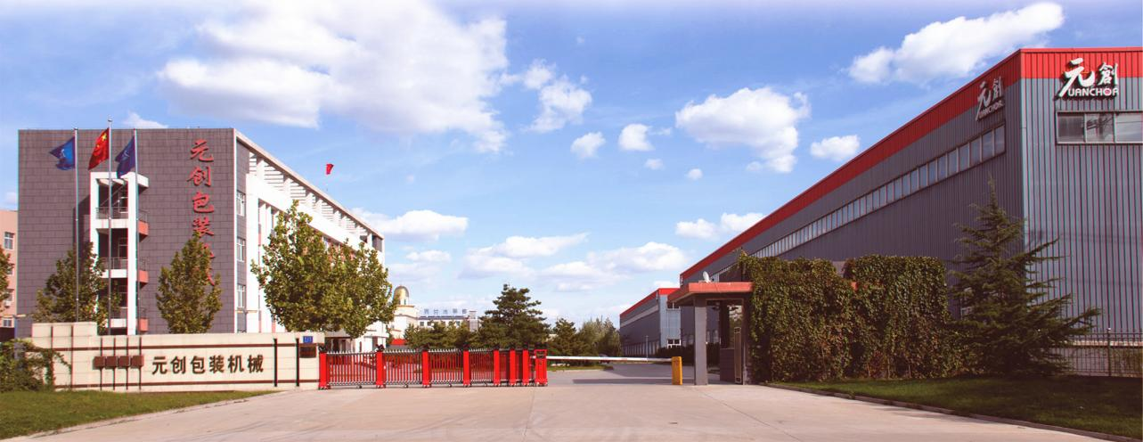
Tangshan UANCHOR Automation Technology Co., Ltd.(Formerly known as Yutian UANCHOR Packaging Machinery Co.,Ltd.) was established in 2009, covering an area of 53.36 mu with a total construction area of more than 25,000 square meters.UANCHOR has 140 employees, registered capital is RMB 30 million and annual output value is more than RMB 90 million.
UANCHOR is "Hebei High-tech Enterprise", "Provincial Enterprise Technology Center", "A-level R & D institution", "Hebei Science and Technology SMEs", "Tangshan Science and Technology Innovation Demonstration Enterprise", "Hebei Specialized and New SMEs", "Hebei Specialized and New Small Giant Enterprise", "Hebei Technological Innovation Demonstration Enterprise".
The main products including 6 series of nearly 20 kinds of optoelectronic integrated equipment, including Automatic Card Slitting and Collating Machine series, Pile Turner series, High Speed Laminating Machine series, Automatic Blanking Machine series, Cutting and Collecting Line series, Digital Inkjet Printing and Inspection Machine series.
Our products serve the domestic printing medium and high-end market and are exported to more than 30 countries and regions such as the United States, Germany, Brazil, Czech Republic, Korea, India, Indonesia, Malaysia and so on.
UANCHOR is located in the center of the "Golden Triangle" of Beijing, Tianjin and Tangshan which is in the economic circle of one hour to Beijing and Tianjin, half an hour to Tangshan. It is near by four major ports and two international airports,it is also near by many high-speed roads with convenient transportation, such as Beijing and Harbin high-speed roads.
In order to better serve customers in East and South of China, UANCHOR invested RMB100 million in Pinghu City, Jiaxing City, Zhejiang Province to establish Zhejiang New UANCHOR Automation Equipment Co., Ltd. in 2018, with a total construction area of 26000 square meters which has been fully put into operation.
UANCHOR insist on the business philosophy of "science and technology, innovation and development" with the purpose of serving customers and society, and makes friends all over the world in good faith.

